**Data Collection Methodology**

**Hardware Set-Up**

The main purpose of this project is to measure the impedance of an earbud/speaker when it is in an enclosed space which is simulated with syringe A. The earphones used for collecting data are listed with their assigned letter as follows:

1. Generic Black earphones with red marking
2. Generic Black earphones with blue marking
3. Generic Black earphone with no connector
4. Generic White earphone with no connector

The earphones will be referred to their assigned letters from now on. We want to allow the earphones to have a good fit in a syringe, their ear-tips are kept on which introduces a gap between the edge of the ear-tip and the “grill” of the speaker. That gap is measured using a caliper:

1. 2.83mm, treated as 3mm
2. 2.28mm, treated as 2mm
3. 2.12mm, treated as 2mm
4. 1.98mm, treated as 2mm

The measuring method is to set Syringe A to the desired length and then insert the earphone and its impedance is measured over a frequency sweep. As previously mentioned, there is a gap introduced by the ear-tip, so a marker line is used as a point of reference and deducted from the measured value based on how deep their ear-tip was. E.g. Measuring 9mm for earphone D, a ruler is used to measure the edge of the marker line to the first ring of the plunger at 7mm. See Figure 1 for the enclosure set-up.

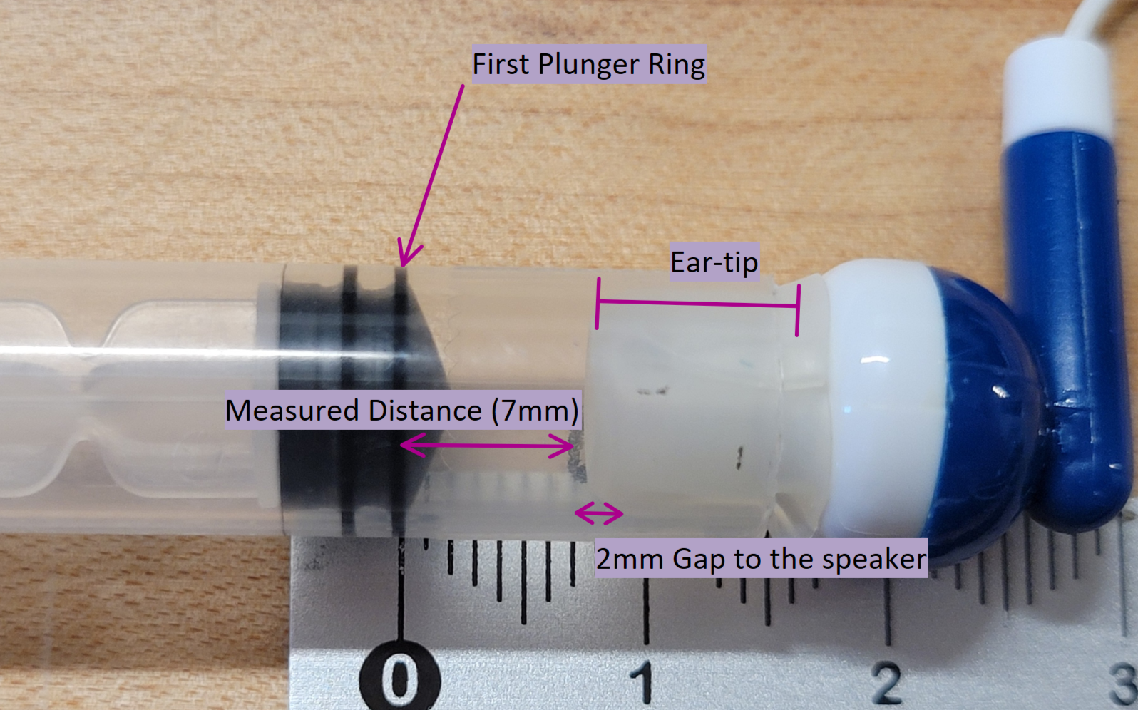

**Figure 1**: Enclosure Set-up

It is important to remove the speaker from the enclosure when adjusting the plunger distance, as the vacuum created by the plunger without removing the speaker will affect the measurement.

Measurements are makes with the Analog Discovery 2 device from DIGILENT. Using the Digilent WaveForms’ software we can measure the impedance and the phase of the device across a frequency sweep across the human hearing range (20Hz – 20kHz) with 501 data points. The function considers a 100 Ω load in series with the device under measurement (the speaker). The process is as follows: connect the hardware, take the measurement through one sweep, and export the data as a CSV file, then repeat. The WaveForms set-up are shown in Figure 2.



**Figure 2** WaveForms Workspace Set-up

Hardware circuitry follows the general set-up shown on the right side of figure 2, the earbud/speaker is the device under test (DUT) and it is placed in series with a resistance (100 Ω resistor). The probes (1+, 2+) are placed across DUT and grounded. This is shown more clearly in figures 3 & 4. The measurement circuit has two options for inputs. The terminal block accepts bare wire speaker connections and the 3.5mm TRS input accepts any stereo 3.5mm jack for earbuds (refer to figure 5). When connecting the TRS connection, the small switch controls whether the left or right side is connected to the rest of the circuit (to the left for L, to the right for R).

**Figure 3** Connection Schematic

**Figure 4** Hardware Set-up

**Figure 5** Measurement Circuit Schematic

*Note: Only one speaker is to be connected at a time. Both stereo and mono connections are shown for explanation purposes.*

**Additional Software**

A custom GUI was created with tkinter in Python, it automates the file saving process as well as repeating the measurement runs. Figure 6 shows the interface, the dropdowns on top left allow the selection of current speaker and distance being measured. The number of repetitions can be changed as well as the other related settings mentioned previously.

**Figure 6** Python GUI Demonstrating 1 run on speaker A at 5mm

As previously mentioned, data is collected on four different earphones/speakers. The distances were determined by taking a measurement every 3mm from 5 to 29mm. Distances measured previously are also included which are Open, Blocked, 9 mm, 14 mm, 24 mm, and 39 mm from the speaker.

**Dataset Guide**

Each sweep sample is stored as one CSV file. The naming convention for the files are as follows: “*Speaker Letter***_***Depth in Milimeters***_***Sample Number***.csv**” with the first sample being Run_1. For example, the file name of the 10th run for speaker B at 5mm is “B_5_Run10**.csv**”. Each run contains 501 data points (rows) with a label occupying the first row. The data collected are listed: "Frequency (Hz)", "Trace θ (deg)", "Trace |Z| (Ohm)", "Trace Rs (Ohm)", "Trace Xs (Ohm)".

If using the python script, it will automatically generate a file structure along where the python file is contained. The automatically generated file structure is shown below:

* Auto Impedance Collection V1.1.py
* Collected_Data
  + A_5
    - A_5_Run1.csv
  + A_8
    - A_8_Run1.csv

The python script will automatically generate a folder for each distance only, it can then be organized by hand, or a later function can be implemented to automatically group the different earphones together under another folder.

For the research project, the dataset is contains 100 runs * 14 distances * 4 earphones = 5600 total measurement files for use with machine learning.